Redux

Benefits

1. With Redux we can check the state of elements and go back to them and check the status of this into UI.

Example:

In a shopping site, we can add a two items to "shopping cart" so the number will be updated into the cart and the general count of the item. With Redux we have all the registry of the items added, user who added, time added, etc.

So with all these details we can check with precision every change into our application and check the history of this.

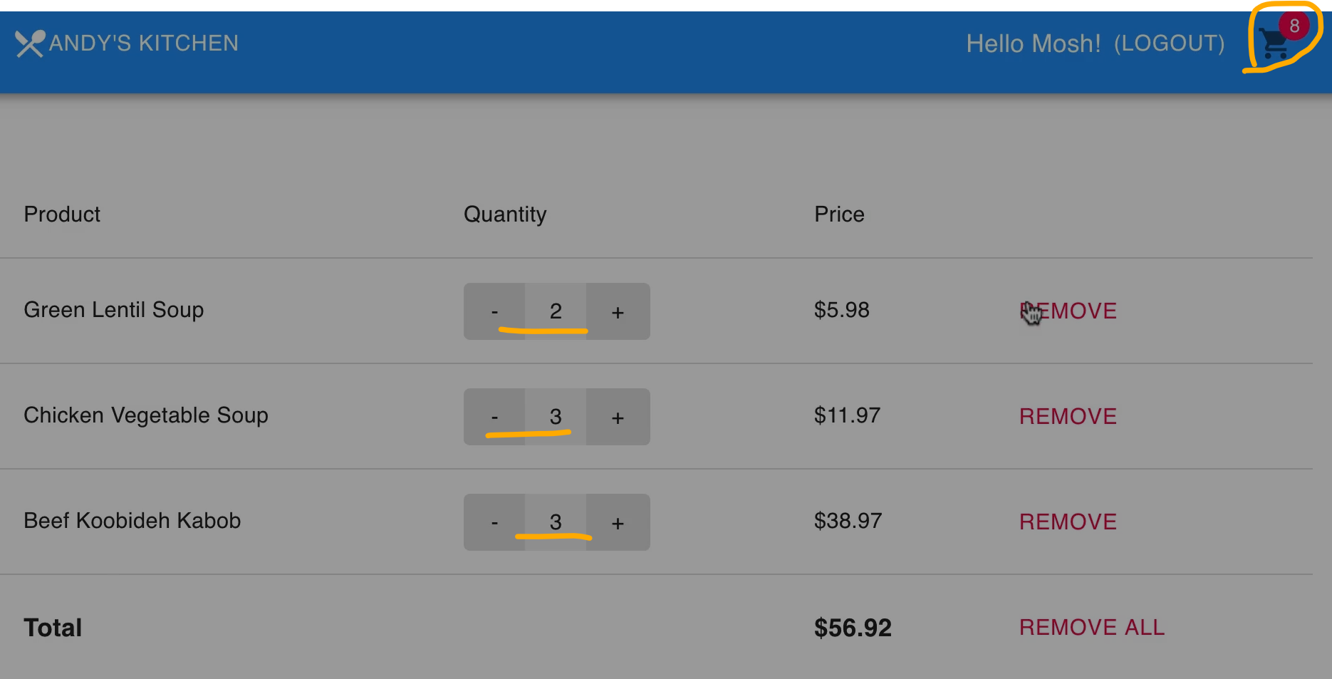
2. Log Rocket tool

With this tool we can check the exact state where the user is seeing, for example:

We developed a new feature and the customer or QA team tell to us the feature is not working properly the we need to ask for the exact steps to be able to reproduce the issue. So with this tool we can go to the exact state the user or QA team is seeing. We don't need to replicate all steps and go and repeat all steps from our side.

This is powerful because can reduce time in testing for a developer, without missing some step in the middle and doing the same process than the users and see the same result.

